Student IT Induction 2021-22

1. Student IT Induction 2021/22

1.1 Welcome
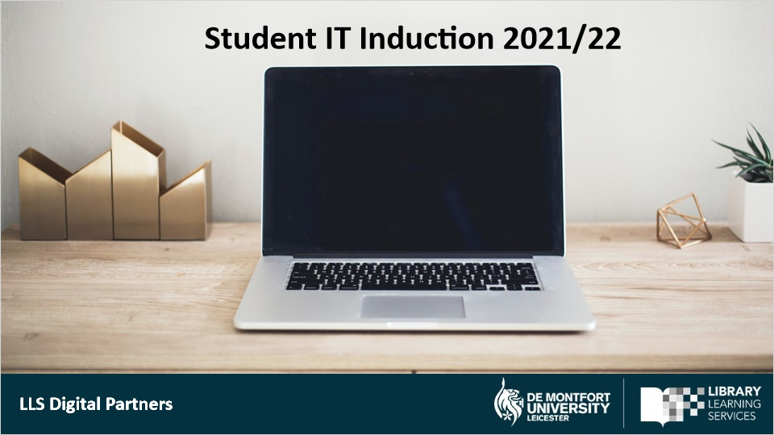
Notes:
Welcome to your DMU Student IT induction presented by the Digital Partners.

1.2 DMU Systems & Technologies
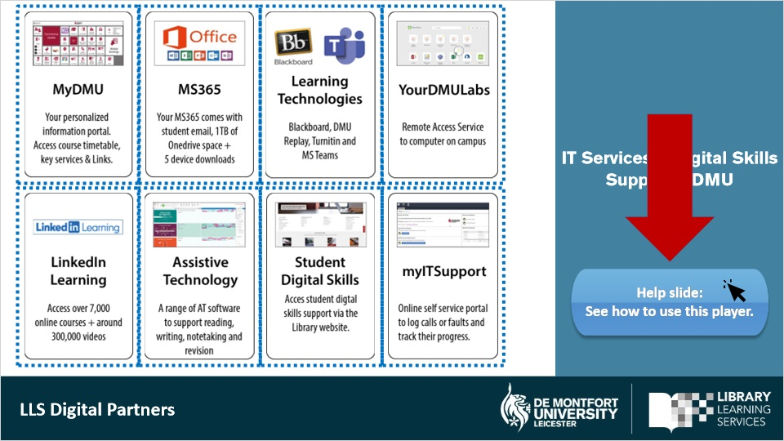
Notes:
There are core technologies and systems that you will be using throughout the duration of your course.
These include MyDMU which is your personalised information portal where you can access your course time table, key services and other important links.

You will also have access to your free DMU MS 365 account, which will allow you to use a variety of apps, such as MS Word, PowerPoint, Publisher and Excel . You will also receive 1TB of Onedrive cloud storage.

You also have Learning Technologies, such as:
- Blackboard (which is your virtual learning environment).
- DMU replay (for play-back of recorded lectures).
- Turnitin (for assignment submissions).
- And other integrated technologies, such as MS Teams.

YourDMULabs will give remote access to a computer on campus.

All DMU students have a free subscription to LinkedIn Learning, which has over 7000 online courses and 300,000 videos for you to further develop your skills and knowledge.

There are a range of Assistive Technology software available at the Library and some are also available as home licences.

You can also access student digital skills support via the Library website and access IT support from ITMS via their myITSupport portal.

This player will move forward to the next slide automatically. You can pause and replay each slide via the controls below. If you would like to see the Help slide about how to use this player, click on the Help Slide button.

Markup Lightbox buttons (Slide Layer)
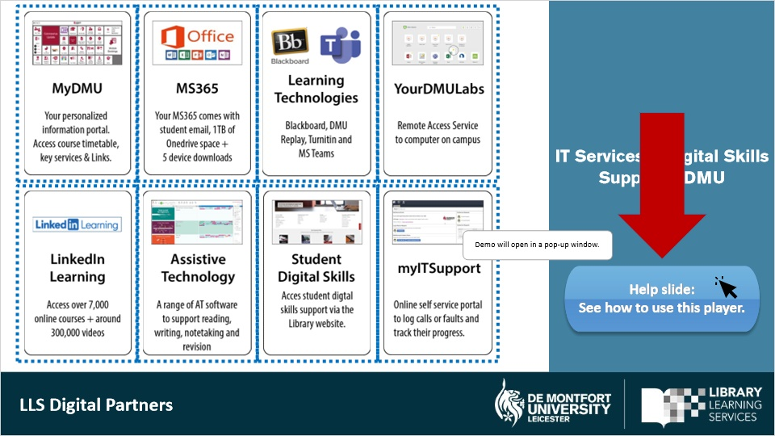

1.3 Username & Password
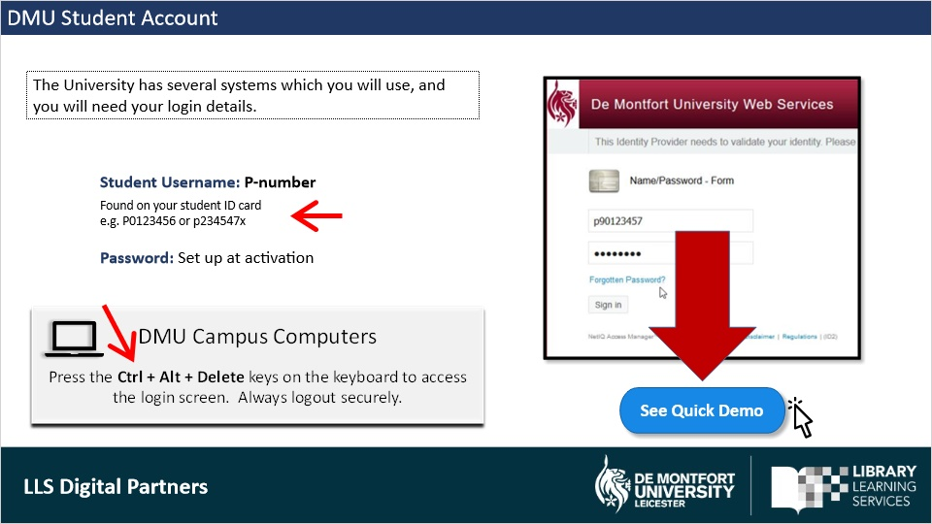
Notes:
You should have received your student ID details as part of your enrolment. You will need these to access and log into DMU systems.

Your username is your P-number which can be found on your student ID card. Use the password you set when you activated your registration.

These same login details are used accessing DMU Campus Computers.

When you login on a Campus computer, press CTRL + ALT + DELETE on the keyboard to access the login screen. Remember to always log out securely.

To see a demo of how to login, click on the Quick Demo button.

Markup Lightbox buttons (Slide Layer)
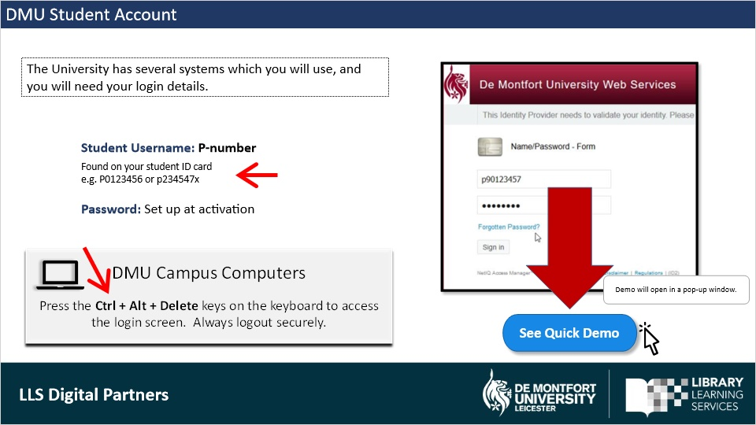

1.4 MyDMU Student Portal
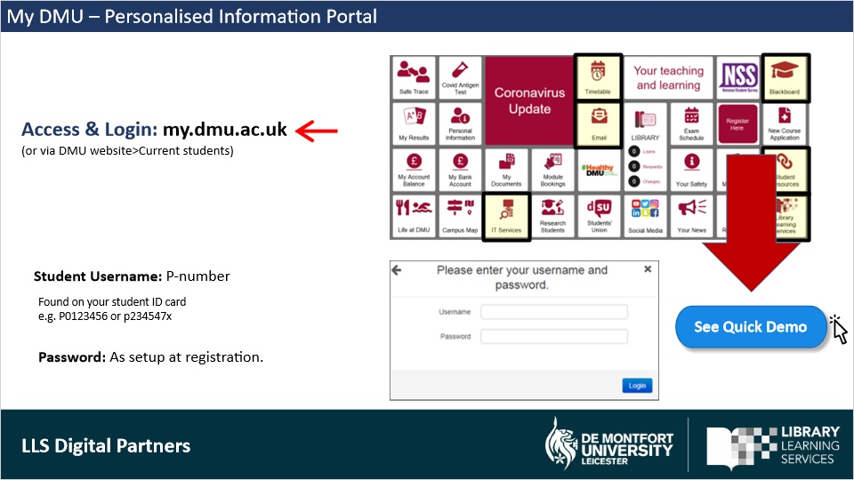
Notes:
MyDMU is your personalised student information portal available 24/7 and can be accessed directly through your web browser by typing in my.dmu.ac.uk.

As you can see from the tiles in MyDMU, you can access key services and information.

Sign in with your username, which is your P-number and is found on your student ID card. Use the password from when you activated your registration.

Spend some time in your student portal and familiarise with the content and services. Here you can, for example, access your personal course timetable, which will also includes links to any online sessions. Online live lessons will be delivered using MS Teams.

As you can see, there are also links here to access your DMU student email, Blackboard (your VLE), MS365, library website, IT Services and much more.
Some tiles will take you to a further menu of links.

If you would like to see a demo on how to login to MyMDU, click on the Quick Demo button.

1.5 Reset Password
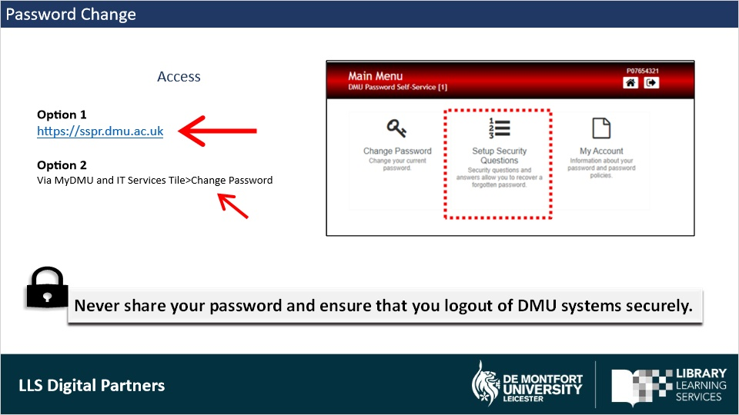
Notes:
If you would like to reset your password, you can manage and change your passwords at https://sspr.dmu.ac.uk/.

You can also set up security questions, so you can reset your password in the event that you forget it.

The ITMS Service Desk can provide assistance if necessary.

This service is also accessible from MyDMU. Click on the IT Services tile and then on the menu link Change Password.

Remember to never share your password and ensure that you logout of DMU systems securely.

1.6 How do you access your Timetable?
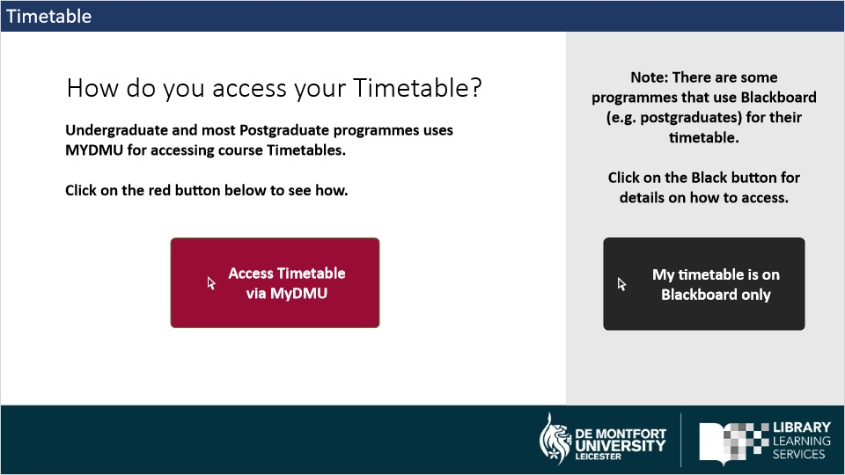
Notes:
Most programmes uses MyDMU for timetables, but there are some programmes that uses Blackboard for their timetables. Select from the buttons, the one that applies to your programme.

Click on the red button for MyDMU or click on the black button if you access your timetable on Blackboard.

1.7 MyDMU Timetable Tile
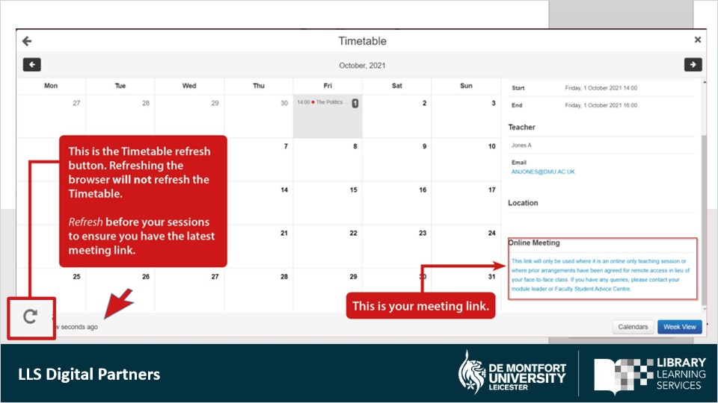
Notes:
You can access your Timetable via the myDMU and Timetable tile.

You may have face-to-face, online, or hybrid sessions. Face-to-Face and hybrid sessions have Building and Rooms numbers in their event details.

The online Teams session links are found under the heading Online Sessions in the MyDMU Timetable.
The meeting URL included in your timetable event details should only be used if it is an online-only teaching session; or where prior arrangements have been agreed for a remote access in lieu of your face-to-face class. If you have any queries about the online links, please contact your module tutor or Faculty Advice Centre .
If a lesson is delivered online, note that some devices/browsers may not be able to connect to Teams via the MYDMU Timetable calendar unless the MS Teams App is installed. It is therefore recommended to install the Teams App on your computer, Smartphone or tablet. To join a sessions, right-click on the meeting link to copy; and then paste into a browser. On Windows use Edge or Chrome. On Macs, use Chrome, not Safari. You will then have the option to continue with Teams in the browser or open the MS Teams App (if installed).
To ensure that you have the latest online session link, click on the Refresh button on the bottom left corner of your Timetable calendar. You can see when you last refreshed the timetable by the notification next to the Refresh button.
It is recommended that you Refresh the link shortly before joining an online session.
If you are working from staff computer or signed in on your browsers with your personal email account, you can use the Incognito Chrome browser mode (or InPrivate mode in Edge) to ensure that you sign in on MS365 and MS Teams as a student and not as a guest. Click on the buttons for the guides.

Untitled Layer 1 (Slide Layer)

Markup Text TT Guide (Slide Layer)
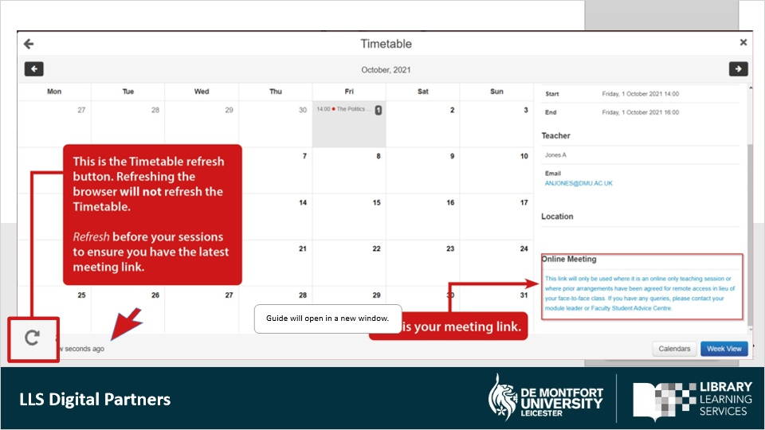

Markup Text Join Teams Guide (Slide Layer)
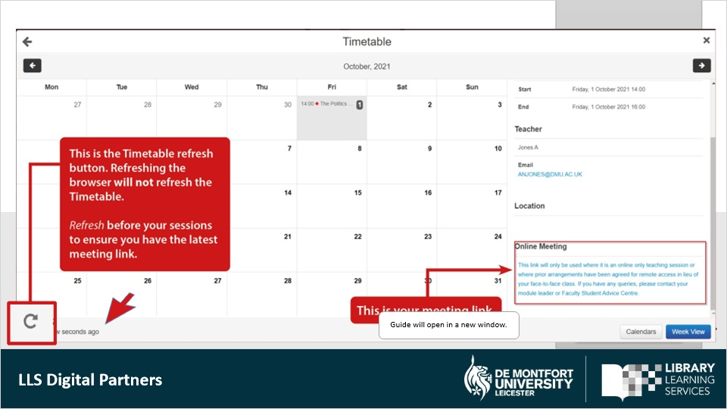

FAQ markup (Slide Layer)
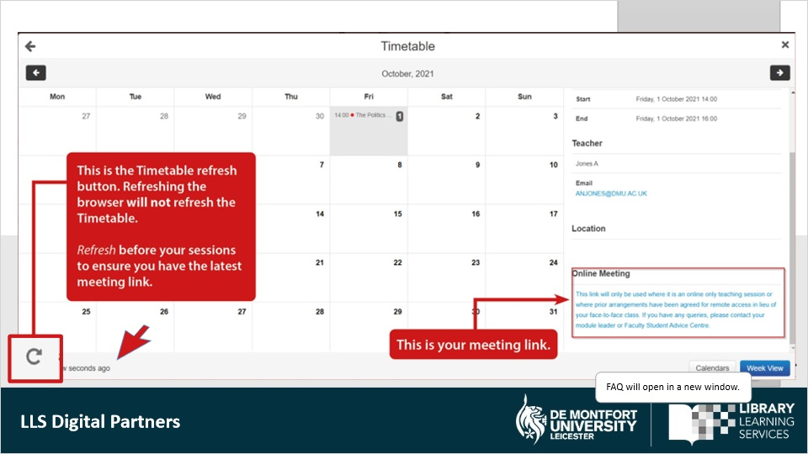

1.8 Your MS 365- Access & Login
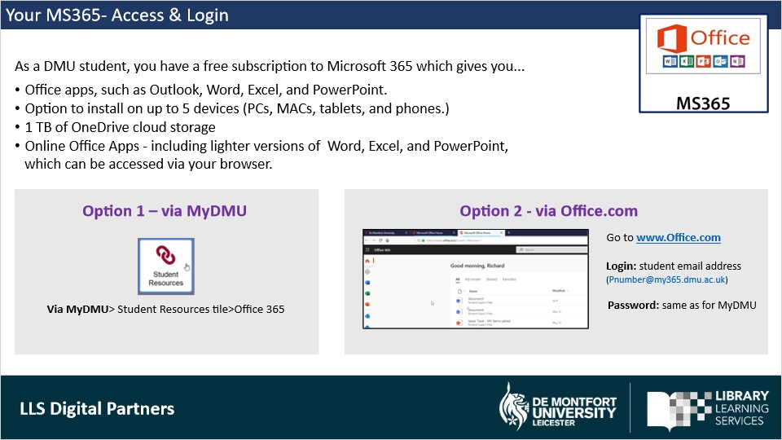
Notes:
All DMU students have free access to Microsoft 365, which allow you to use a variety of apps such as MS Word, PowerPoint and Excel. MS Teams is used to join online sessions but can also be used to work collaboratively on group projects or to chat with your class mates.

You have the option to install on up to 5 devices (PCs, Macs, tablets, and smartphones); and you also get acces to online Office Apps - which are lighter versions of Word, Excel, and PowerPoint.

There are two ways to Access & Log into MS365.
Option 1 is via MyDMU and the Student Resources Tile.
Option 2 is logging on directly via Office.com

Remember to sign in with your student email and DMU username & password when prompted.

1.9 Download MS365
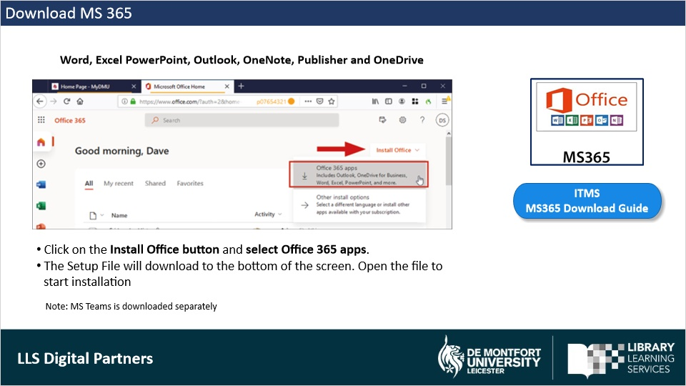
Notes:
You can download Office via Office.com.

Once you have signed in, click on the Install Office button and select Office 365 apps from the drop-down options. The Setup File will download to the bottom of the screen in your browser. Once the donwload is complete, open the file to start the installation.

MS Teams is essential for live teaching session and to work on group projects, but it will need to be downloaded separately. We will cover this in the next slide.

To the ITMS guide on how to download MS365, click on the blue button.

Markup Text Download Guide (Slide Layer)
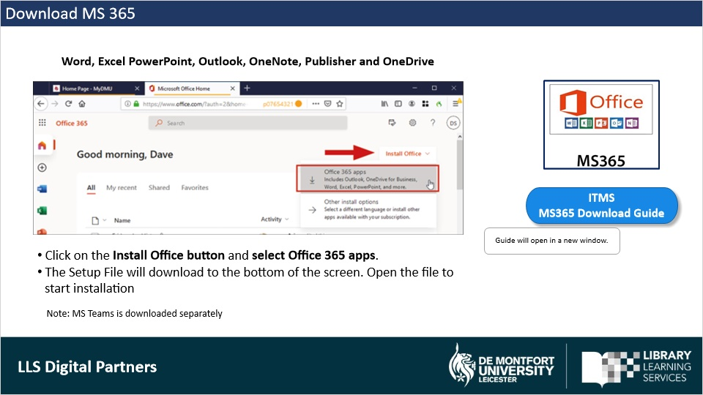

1.10 Download MS Teams
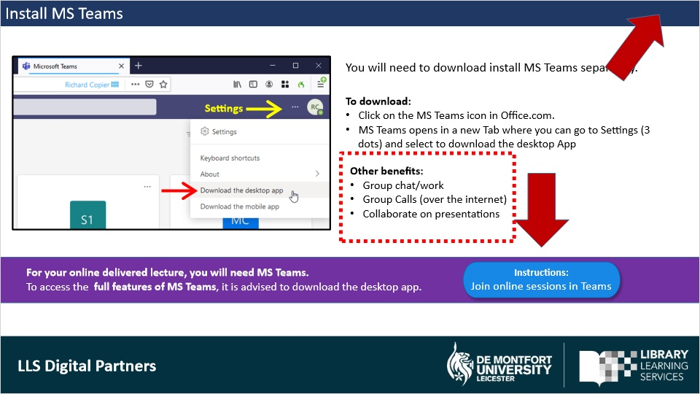
Notes:
You will need to install MS Teams separately.

Remember you will have meeting URL links for online delivered lecturers, so it important to have Teams ready so you can join the session online.

To access the full features of MS Teams, best to download the desktop app.

To download, click on the MS Teams icon in Office.com. MS Teams opens in a new Tab where you can go to Settings (via the 3 dots next your profile icon) and select to Download the desktop app.

You can also access Teams from the browser, but features may limited depending on which browser you use. When you click on a meeting link from your online Outlook Calendar, it will give you the option to continue in the browser or open the MS Teams desktop app.

Other benefits of using Teams:
- Group chat
- Group Calls (over the Internet)
- Collaborate on presentations
- Your tutor may use teams in teaching

There are several ways to join online sessions. Click on button to see the Join Sessions in Teams instructions.
In the Resources tab on the Player, you will also find a guide on how to get started with MS Teams.

Markup Text Join Teams sessions button (Slide Layer)
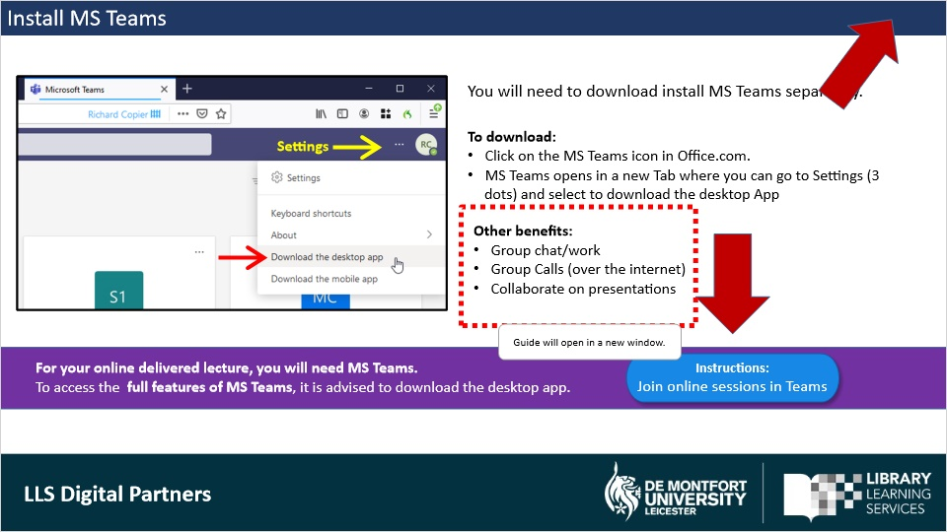

1.11 Outlook Student Email & Calendar
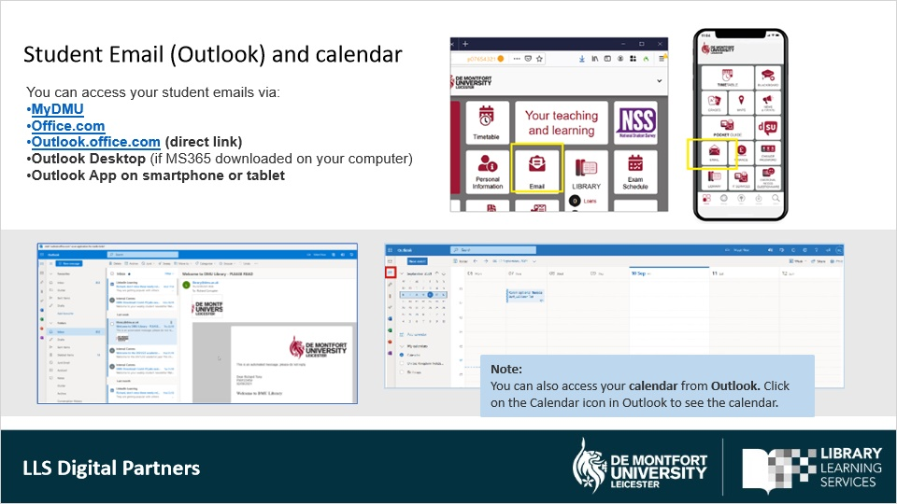
Notes:
You access your student email via Outlook as part of MS365.

This is the official email that the university, the library and your tutors will use to communicate with you, so make sure to check it on a regular basis.

There are many ways to access Outlook:

You can go via MyDMU and the Email Tie
Or go to Office.com and click on the Outlook icon
You can also go direct by typing in outlook.office.com in your browser

If have installed Office, you can access your student email from the Outlook Desktop app.
With the Outlook mobile app you can also stay connected on the go.

1.12 OneDrive
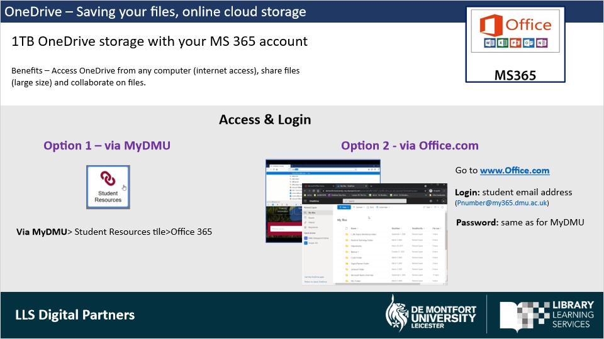
Notes:
OneDrive is a your online cloud storage where you can save and backup your files e.g. Word, Excel, PowerPoint and video files.
All students receive 1TB storage.

There are many benefits to using OneDrive. For example, you can access it from any computer with an Internet access, share files and collaborate on project work if needed.

There are two ways to login to OneDrive:
Option 1 is via MyDMU and the student resources tile; and then click on the MS365 link.
Option 2 is directly via Office.com and click on the Onedrive icon. Use your student email to login when prompted.

1.13 Blackboard My Modules
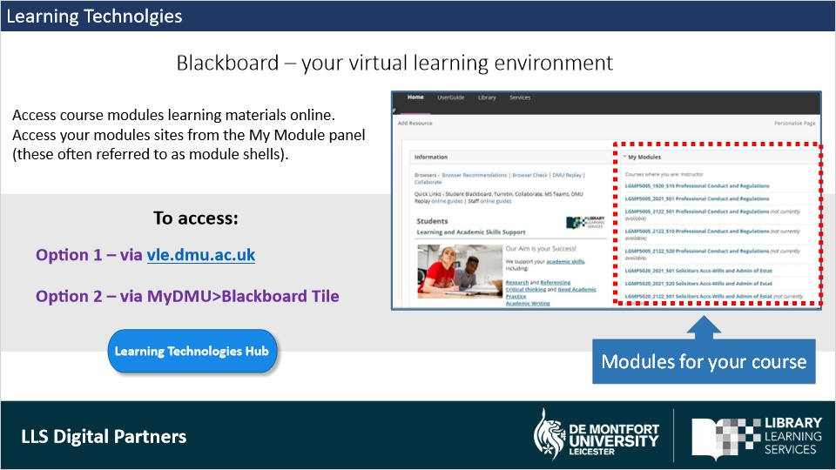
Notes:
Blackboard is a web-based virtual learning environment used at DMU to support your learning, teaching, and assessment.

Blackboard provides access to recorded teaching sessions and learning materials from any computer with internet access. In your personalised home page, you can access and view the course modules that you are enrolled on. You can access your modules from the My Module panel on the right, as you can see on the slide. These often referred to as module shells.

You will be accessing Blackboard regular basis, so it is important to familarise yourself with the platform.

You can access and login directly to Blackboard by typing vle.dmu.ac.uk in your web browser. Or, you connect via the Blackboard tile in MyDMU.

1.14 Module Site
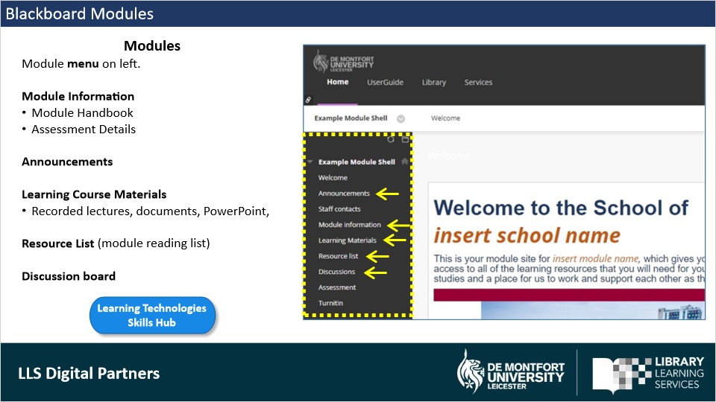
Notes:
On selecting a module – your will see your module site. What you see here is a typical layout, but it may slightly differ depending on your lectures content. Spend some time navigating the module and the content.

As you can see, the module menu is on the left and typically includes:

- Module Information where you will find the Module Handbook with important details about the module and how you will be assessed.
- Module Announcements are posted by the lecturers.
- Learning Course Materials will contain documents and PowerPoints uploaded by your tutor. In here, you may also find recorded lectures, which you can revisit and replay via DMU Replay.
- Resource List is your module Reading list.
- If Discussion Boards have been added by your tutor, it will appear as on the menu as well.

Markup Text LT guide (new) (Slide Layer)
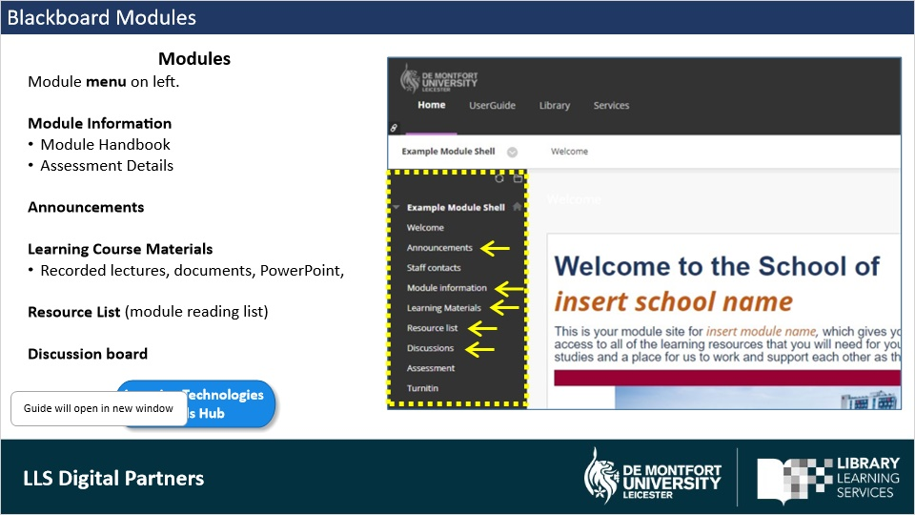

1.15 Turnitin – Assignment submission
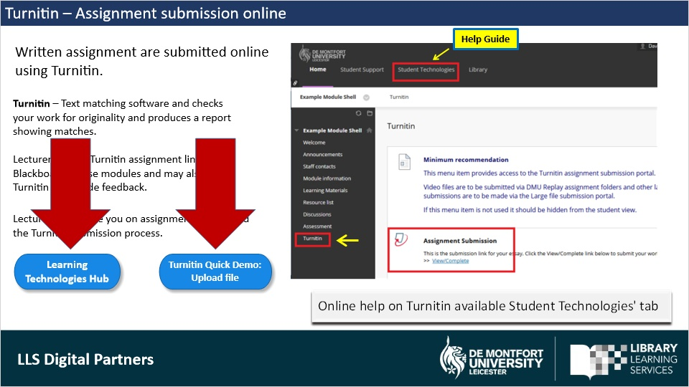
Notes:
Written assignment are submitted online via Turnitin in your Blackboard module.

Turnitin is a text matching software and checks your work for originality and produces a report showing matches found.
Lecturers set up Turnitin assignment links in Blackboard course modules and may also use Turnitin to provide feedback.
Lecturers will guide you on assignment criteria and the Turnitin submission process., but there is also online help on Turnitin via the Student Technologies tab in Blackboard.
You can also click on the blue buttons to see the Learning Technologies guide or see a quick demo of the uploading a file.

Markup Text LT guide (new) (Slide Layer)
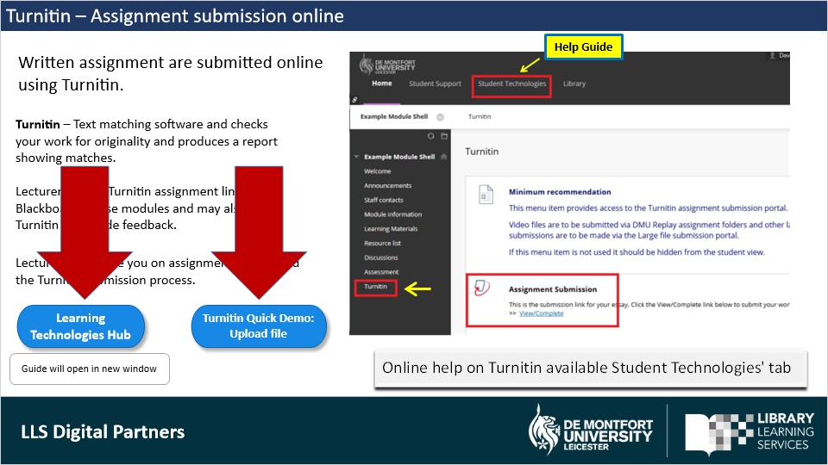

Markup demo (Slide Layer)
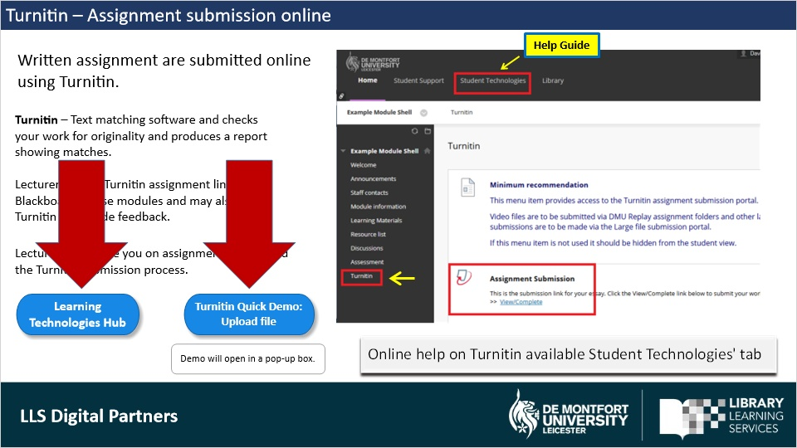

1.16 Multi factor Authentication
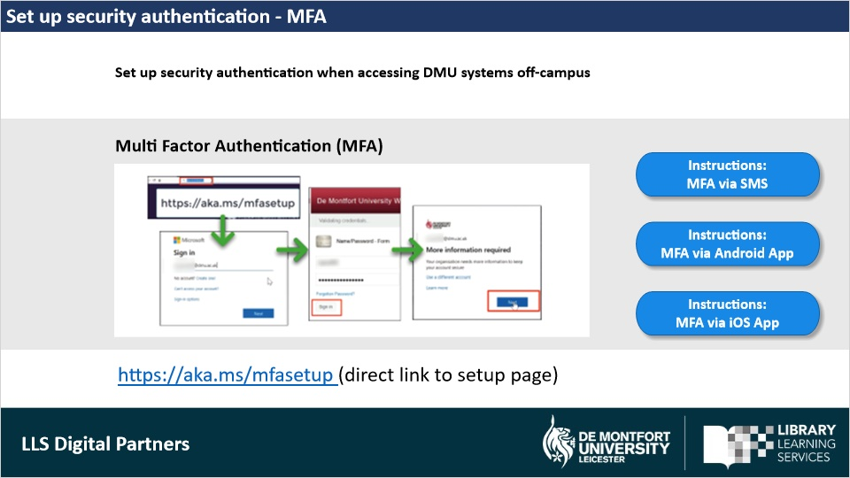
Notes:
To enhance security, we will be adding a security authentication layer called Multi Factor Authentication (MFA) for when you acces your MS365 apps and your student email off-campus.

It is a simple process to register your preferred MFA method, e.g. use either a mobile app or an SMS text message . We recommend doing this as soon as possible to avoid disruption when it is enforced. You will only need to do this once.

To setup go to https://aka.ms/mfasetup and sign-in with your student email. Follow the on-screen instructions to complete the set up.

You can also click on the blue buttons for instructions on how to set it up.

Markup Text SMS (Slide Layer)
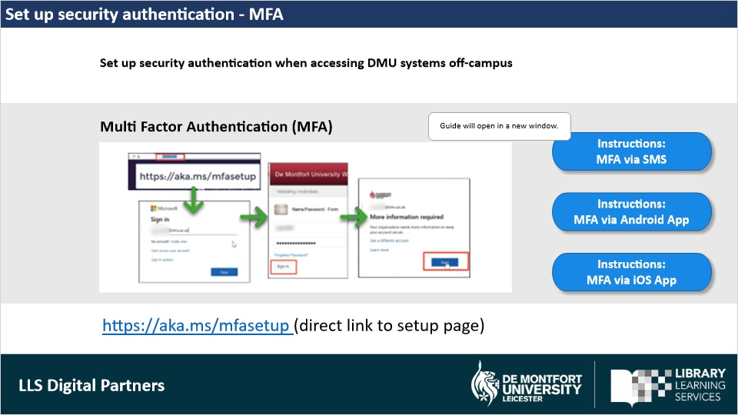

Markup Text APP (Slide Layer)
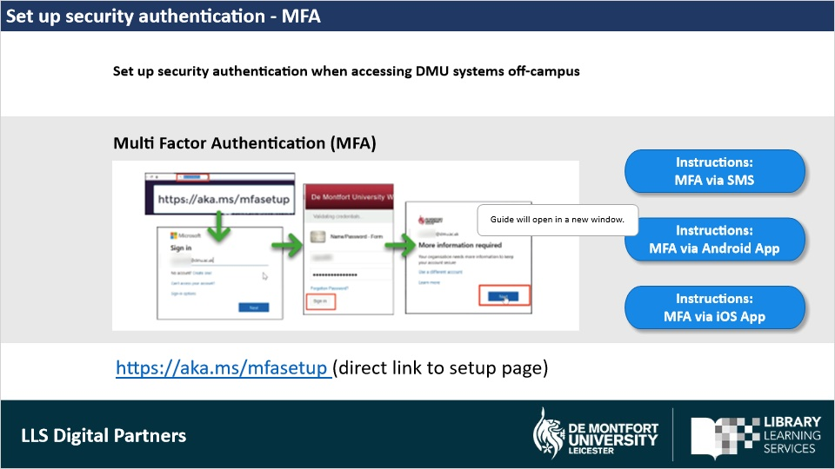

Markup Text APP iOS (Slide Layer)
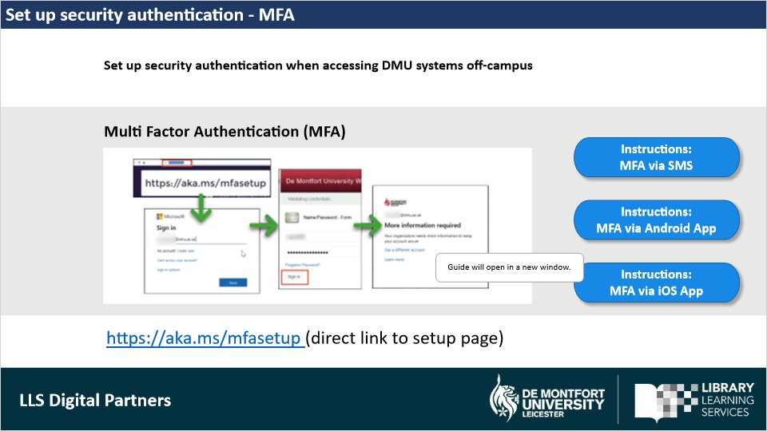

1.17 IT Support (ITMS)
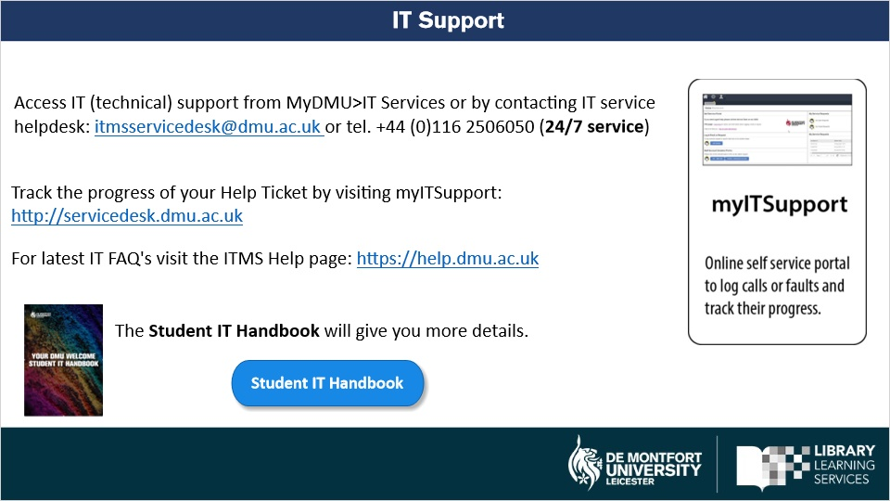
Notes:
Access IT (technical) support by contacting the ITMS service helpdesk via their email itmsservicedesk@dmu.ac.uk or call +44 (0)116 2506050

ITMS can assist with technical issues to do with MFA, logins and Learning Tech issues in Blackboard, Turnitin, Teams, MS365, and so on

Track the progress of your technical queries by visiting
http://servicedesk.dmu.ac.uk

For latest IT FAQ's visit https://help.dmu.ac.uk

Markup Text Download Guide (Slide Layer)
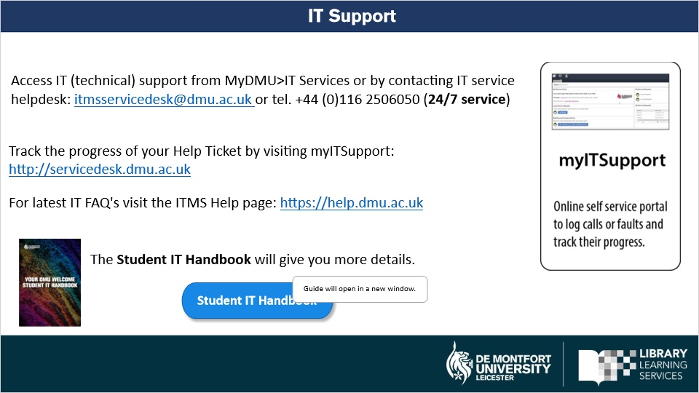

1.18 Student Digital Skills Support
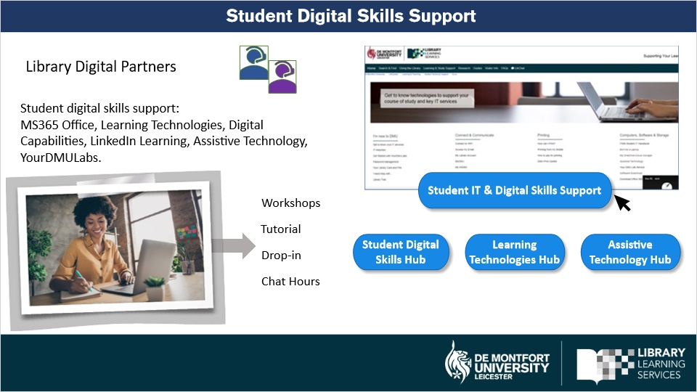
Notes:
The Library Digital Partners provide student digital skill support and development for MS 365, Learning technologies, digital capabilities, assistive technology and other technologies mentioned in this presentation.

Support is provided through our online workshops, tutorials, online drop-ins and chat hours.

Our services and information are accessible from the library website and our Student Digital Skills and IT support pages.

We also have online how-to guides available on our three online skills hubs: Student Digital Skills, Learning Technologies and Assistive Technology.

Markup Text DP button (Slide Layer)
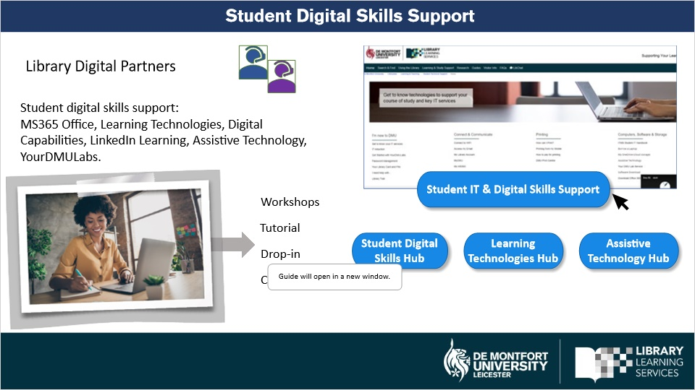

Markup Text LT button (Slide Layer)
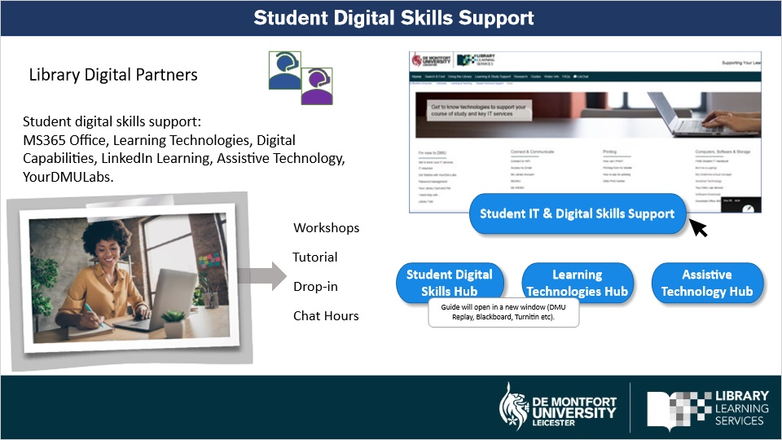

Markup Text AT button (Slide Layer)
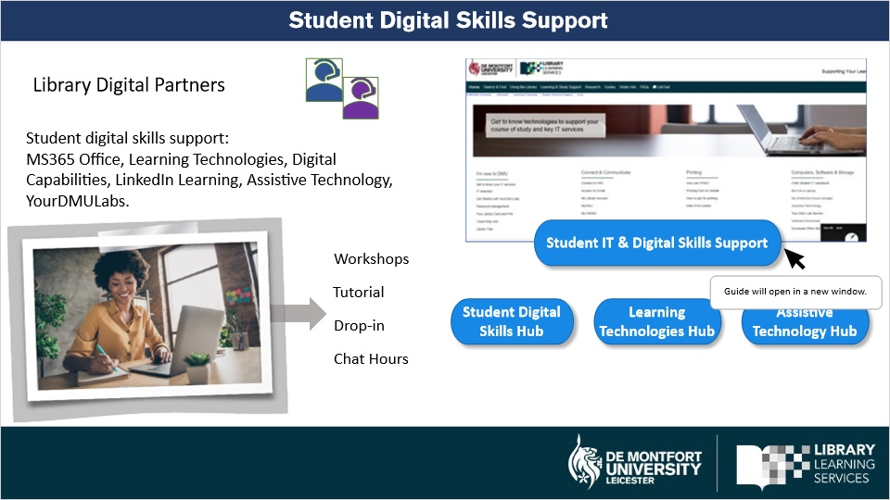

Markup Text IT and skills support (Slide Layer)
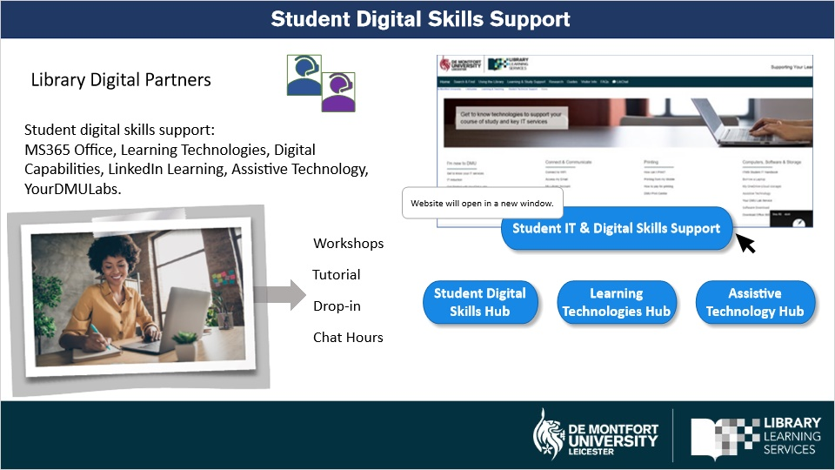

1.19 IT and Digital Skills contacts
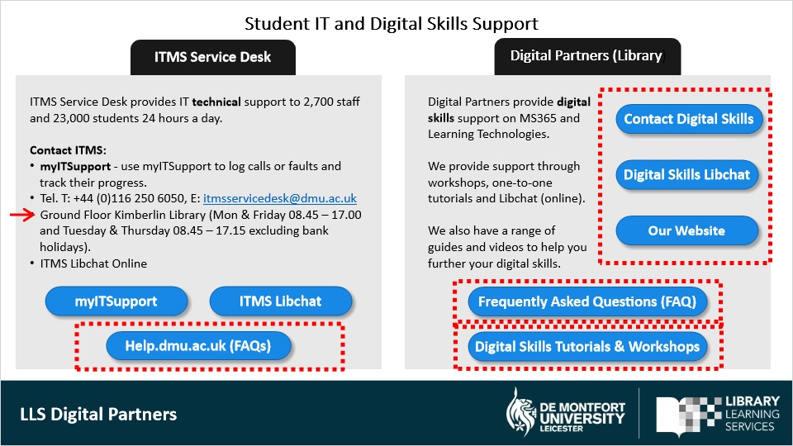
Notes:
On this slide you find an overview of the IT and Digital Skills support available at DMU.

Please click on the buttons to explore further or to bookmark pages.

Note, that the ITMS service desk is also available on the ground floor in the Kimberlin Library.

Remember, you can contact Digital Partners for digital skills queries and book onto our workshops and tutorials throughout the academic year. We can help with how-to questions. For example, you may wish to learn how to format a Word document for a written assignment that requires a Report format. Or, you may wish to find out how to create a diagram in Excel. Or even how to create a Poster in MS Publisher.

Please do not hesitate to check out our Frequent Asked Questions and the ITMS Help page.

1.20 Further Information
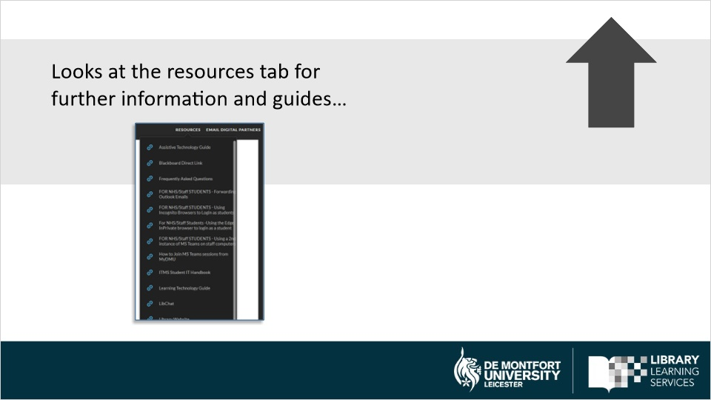

2. Help Slide: How to use this Player

2.1 Player layout and buttons
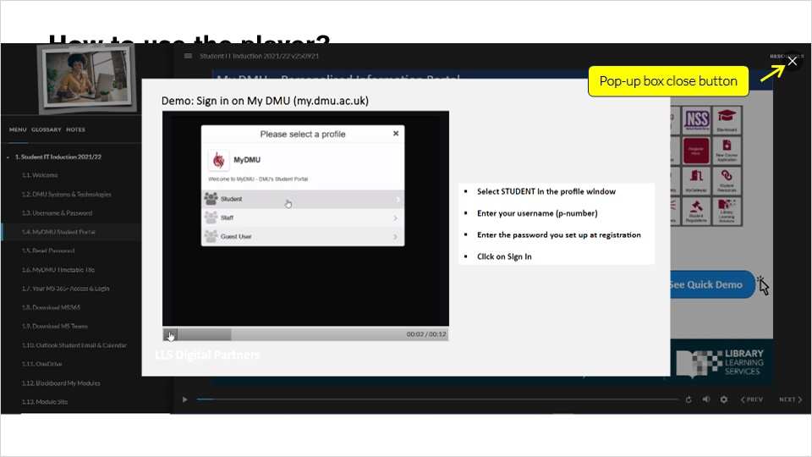
Notes:
On the left, you will see the content menu with numbered slide titles.
You can jump forward or backwards to any slide by clicking on the title.
There is also a Glossary tab and a Notes tab. The Notes tab contains the audio transcript of this slide.

Below you will see the play- back progression bar. When it reaches the end, the player will automatically jump to the next slide.

On the bottom right, you can use the Previous and Next buttons to move to the next slide or back to a previous slide.
In Settings, you can enable Accessibility Text to work with custom styles and enable Fit-to-Zoom.
You can control the volume of the audio via the Volume button.
You can also turn on Closed Captions, by clicking on the CC button.
If you would like to replay the slide, click on the Replay button.

Top right, you will see a Resources button where we have added resources that may be of interest. Blue buttons on slides may open online guides or open a pop-up box. You can close the box from the X in the top right-hand corner.

And finally, you can collapse the Content menu panel by clicking on the Menu button on the top left.

You will also find active hyperlinks in some of the slides.

3. Demo Slides

3.1 Single-Sign-On SAML Login
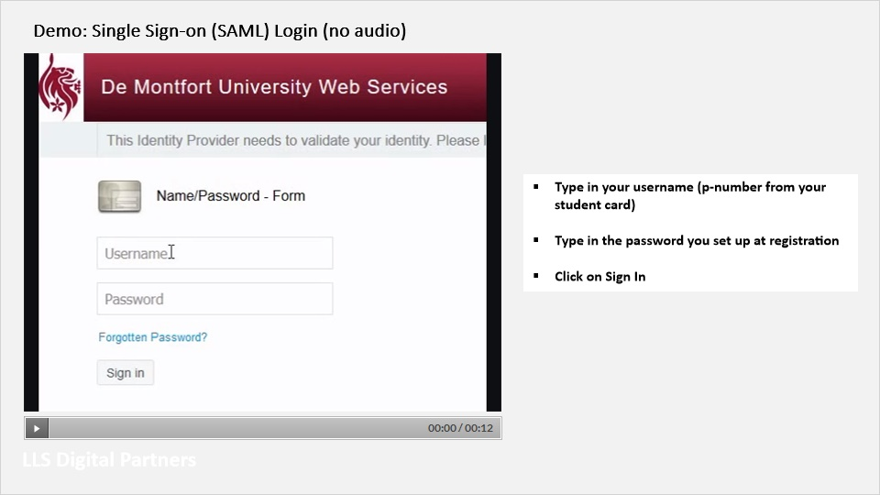
Notes:

3.4 Timetable on Blackboard
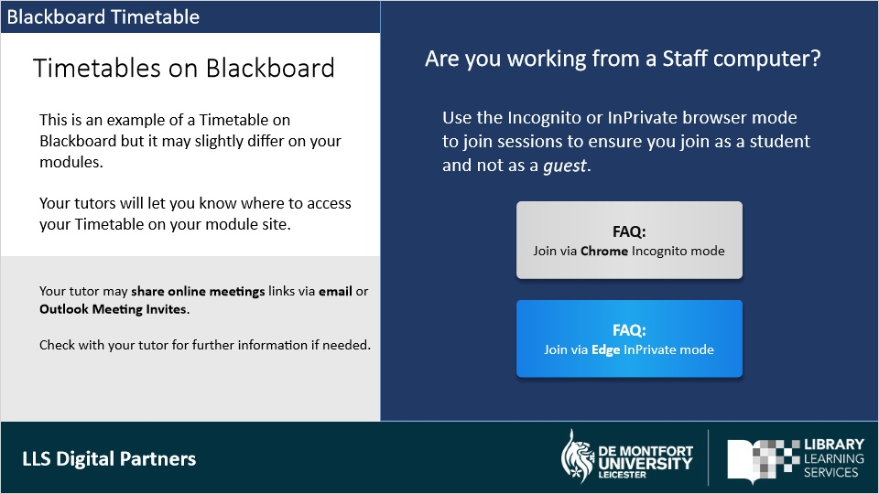
Notes:
Here is an example of a Timetable on Blackboard. it may slightly differ on your modules. Your module leaders will let you know how to access your Timetable on your module site.

Your tutor may share online meetings links via email to your student email inbox or via Outlook Meeting Invites. Check with your tutor for details if needed.

Click on the next button to continue.

